The Artist
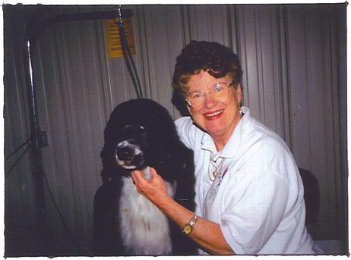
Claire McLean with her beloved Portuguese Water Dog American, Mexican, Bermudian, Luxembourg, Dutch, International Champion Deewal Intrepid
Claire McLean, founder and President of the Presidential Pet Museum, graduated from Bucknell University in 1955 with a degree in Art and English. Many years followed as a mother of four children, homemaker and breeder of Bouvier des Flandres and Portuguese Water Dogs. Breeding under the Deewal prefix, became an AKC judge of the Bouvier & Portie. She started the Presidential Pet Museum stemming from her brief adventure to the White House to groom then President and Mrs. Reagan’s Bouvier dog, Lucky.
Along with breeding and showing dogs, Claire’s paintings are in homes all across America due to her prolific painting and travels as an Air Force Wife. Her style is very distinctive and varies between impressionism and folkism. In earlier years she had many showings and won awards too numerous to name. The Pet Museum and her paintings will assure Claire McLean’s legacy into the next decades.

